**Integrated Science Unit 1**

**Task 1: Practical Skills Assessment**

**Task Type : Science Inquiry**

**Weighting of Task : 6 %**

Name: _____________________________

1. There are THREE SECTIONS in this science inquiry activity. You must attempt ALL sections.
2. You are not permitted to use your notes.
3. The time allowed to complete the questions is 60 minutes.

|  |  |  |
| --- | --- | --- |
|  | **Marks Allocation** | **Your Total** |
| **Section One** | 13 |  |
| **Section Two** | 25 |  |
| **Section Three** | 14 |  |
| **TOTAL** | 52 |  |
|  | | Percentage % |

**Practical Skills Assessment**

In this section you are going to carry out a practical and record and analyse your results. This will involve setting up a microscope, preparing a slide for viewing and recording your results.

**Section One**

1. Label the diagram of the microscope correctly. (4 marks)

Objective lens

Stage

Diaphragm/iris

Fine focus

Course focus

arm

C grade

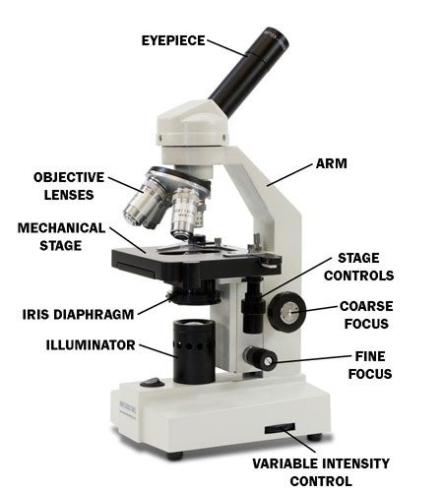2 =1 mark

4 = 2 marks

Eye piece/ocular /body tube

6 = 3 marks

8 = 4 marks

lamp

1. Describe how you would prepare a wet mount slide of plant tissue for viewing under the microscope. Ensure it is a step by step procedure using correct terminology. (4 marks)

*Explain the process in detail, correct terms and scientific language = A (4 marks) – sample on slide, cover with 2-3 drops of water, coverslip on angle then lower to ensure no air bubbles, drop of stain at side draw through with tissue paper/filter/paper towel.*

*Explanation brief and uses correct language = B (3 marks)*

*Explanation brief and some terms = C (2 marks)*

*Some procedure lacing scientific terms = low C (1 mark)*

1. State why the plant tissue would be stained prior to viewing under the microscope. (1 mark)

To enable the organelles to be seen clearly = 1 mark B grade question

1. Once the microscope slide has been secured for viewing, describe the initial steps you would take to focus on the cells in the tissue. Ensure it is a step by step procedure, including the correct terminology. (4 marks)

*Explain the process in detail, correct terms and scientific language = A (4 marks) – place slide on stage, raise stage to just below objective lens, turn so using low power, use coarse adjustment to bring into view, then fine to bring into focus*

*Explanation brief and uses correct language = B (3 marks)*

*Explanation brief and some terms = C (2 marks)*

*Some procedure lacing scientific terms = low C (1 mark)*

**Section Two**

During the following practical you will be assessed on your ability to prepare a microscope slide for viewing and the accuracy of recording information.

**Hypothesis**: If the chemical composition of a substance is different then the crystals they form during evaporation will be different in shape.

1. State the following:

Independent Variable: chemical composition of substance (1 mark) C grade

Dependent Variable : type of crystal formed (1 mark) C grade

**Collect the following equipment:**

Microscope

Four microscope slides

Saturated solutions of Sodium Chloride, Aluminium Potassium Sulphate, Copper Sulphate, Magnesium Sulphate

Small dropper bottle of ethanol

Test paper

Below are a set of instructions to create a microscope slide for watching salt crystal grow. When you have completed the first activity repeat the process using the other saturated solutions (one at a time).

1. Place a small drop of salt solution onto the middle of the microscope slide.
2. Place the slide onto the microscope.
3. Using the low power, focus the microscope of the slide.
4. Then add a drop of ethanol to the solution and watch the crystals grow using the microscope.
5. Once the crystals have grown, try focusing the slide using the medium power.
6. Record what you see under the microscope on the following page.
7. Repeat steps 1-6 using the other saturated chemicals.

**You will be marked on the following:**

Safety in the laboratory safety equipment on, safe use of chemicals (2 marks) C grade

Preparation of a microscope slide sample, drop of chemical, small amount of ethanol (2 marks) C grade

Appropriate use of a microscope to view a sample

stage correct height, low power focus, coarse focus first (3 marks) C grade

Appropriate care of laboratory equipment wash slide after use, put equipment away (2 marks) C grade

1. Record your results in the spaces below. 1=names, 1 per drawing if accurate (5 marks)

Copper Sulphate solution Sodium Chloride



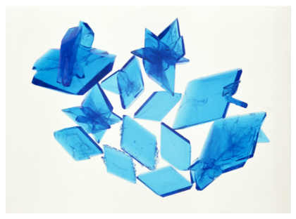

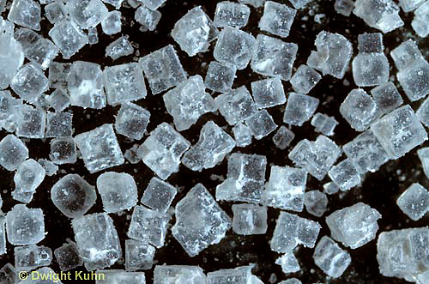

Aluminium Potassium Sulphate Magnesium Sulphate



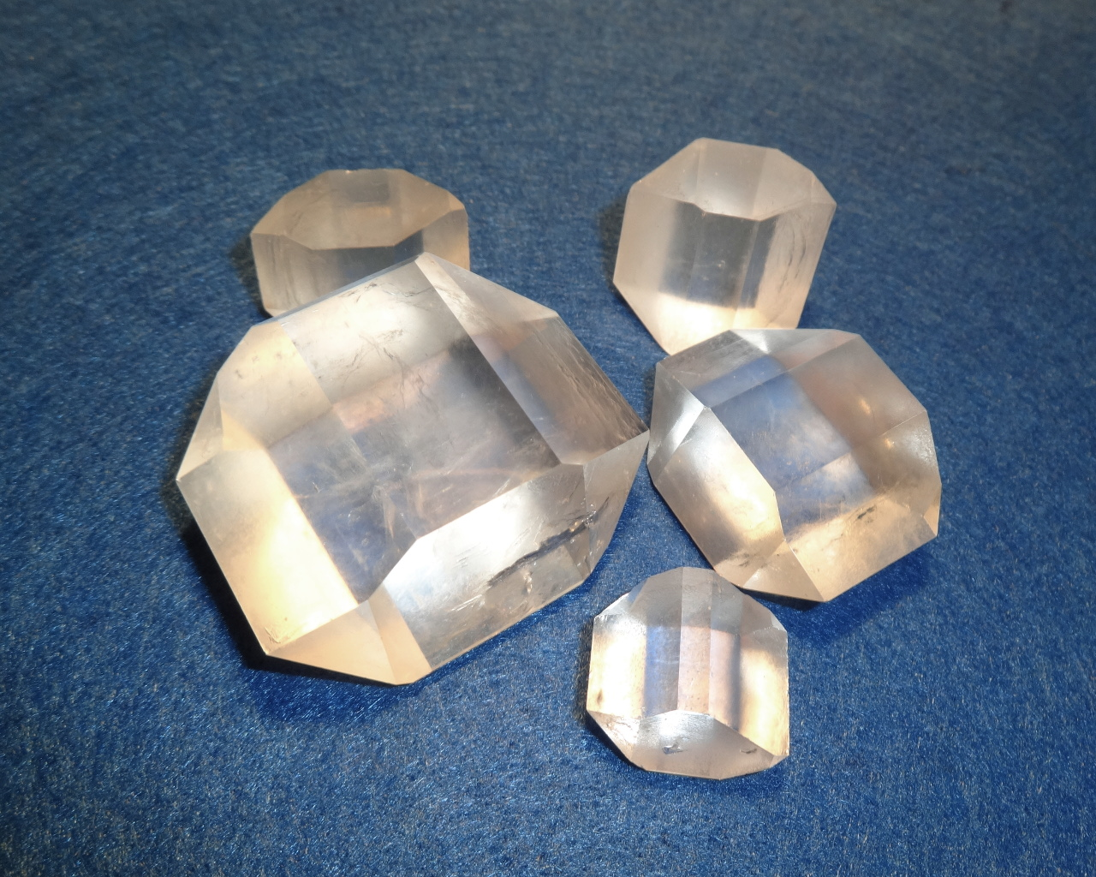

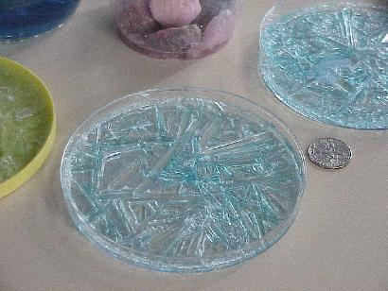

1. Describe the crystal formation for each type of saturated solution. 1 mark each description

(4 marks)

CuSO4 – large crystals, rhombus (parallelogram), big, blue

NaCl – cube shaped small few across slide

AlKSO4 – hexagonal shaped, 3d, small

MgSO4 – long, thin needle like crystals, lots

1. Write a conclusion for your experiment. (2 marks)

*The crystal formed by the different chemicals were different shapes (1 – inclusion of results* C grade*), therefore the hypothesis was correct in that different substances will form different shaped crystals(connection to hypothesis – 1 mark* A grade*)*

1. Describe any difficulties you experienced in conducting this experiment and suggest a way that the design of the investigation could have been improved. (3 marks)

Eg crystals too small to see the actual shape (1 mark), experiment could have been improved by growing the crystals first in a container (1 mark) and then viewing the crystals because they would be bigger and easier to see their shape (1 mark)

Identifies areas where inconsistencies occurred and suggest appropriate way to improve investigation – A grade

Identifies area of error and gives general suggestion – B grade

Identifies a difficulty but suggestion vague – C grade

**Section Three**

A science student set out to investigate the reason why the fish were active when the temperature was quite warm. A controlled experiment was designed in which groups of fish were subjected to different temperatures. The following data were collected.

# Temperature of Number of Number of Total Number

the container fish active fish inactive of fish in the

(oC) pond

0 0 50 50

10 4 46 50

15 8 42 50

20 18 32 50

25 40 10 50

30 48 2 50

35 11 39 50

40 2 48 50

45 0 50 50

##### Question 1

What hypothesis could the science student have been testing? (2 marks)

*If you increase the temperature of the water the fish are in (1 mark) then the fish will become more active (1 mark) Two marks if both independent and dependent included appropriately (B – grade) and one mark if hypothesis testable but not worded correctly (C – grade)*

##### Question 2

In the above experiment which is the:

(i) Independent variable? The temperature of the water (1 mark –C grade) + 0 – 45 degrees

(2 marks B grade)

(ii) Dependent variable? The activity level of the fish (1 mark) C grade

##### Question 3

State 2 variables the student would need to control in order to collect reliable data? (2 marks)

*2 controlled appropriate variables with specific details (2 marks) A - grade*

*2 controlled variables with no specific details (1 mark) B - grade*

##### Question 4

On grid provided plot a graph to show how the number of active fish changed over time as the temperature changed. (5 marks)

|  |  |  |  |  |  |  |  |  |  |  |  |  |  |  |  |  |  |  |  |  |  |  |  |  |  |  |  |  |  |  |  |  |  |  |  |  |  |  |  |  |  |  |  |  |  |  |  |  |  |
| --- | --- | --- | --- | --- | --- | --- | --- | --- | --- | --- | --- | --- | --- | --- | --- | --- | --- | --- | --- | --- | --- | --- | --- | --- | --- | --- | --- | --- | --- | --- | --- | --- | --- | --- | --- | --- | --- | --- | --- | --- | --- | --- | --- | --- | --- | --- | --- | --- | --- |
|  |  |  |  |  |  |  |  |  |  |  |  |  |  |  |  |  |  |  |  |  |  |  |  |  |  |  |  |  |  |  |  |  |  |  |  |  |  |  |  |  |  |  |  |  |  |  |  |  |  |
|  |  |  |  |  |  |  |  |  |  |  |  |  |  |  |  |  |  |  |  |  |  |  |  |  |  |  |  |  |  |  |  |  |  |  |  |  |  |  |  |  |  |  |  |  |  |  |  |  |  |
|  |  |  |  |  |  |  |  |  |  |  |  |  |  |  |  |  |  |  |  |  |  |  |  |  |  |  |  |  |  |  |  |  |  |  |  |  |  |  |  |  |  |  |  |  |  |  |  |  |  |
|  |  |  |  |  |  |  |  |  |  |  |  |  |  |  |  |  |  |  |  |  |  |  |  |  |  |  |  |  |  |  |  |  |  |  |  |  |  |  |  |  |  |  |  |  |  |  |  |  |  |
|  |  |  |  |  |  |  |  |  |  |  |  |  |  |  |  |  |  |  |  |  |  |  |  |  |  |  |  |  |  |  |  |  |  |  |  |  |  |  |  |  |  |  |  |  |  |  |  |  |  |
|  |  |  |  |  |  |  |  |  |  |  |  |  |  |  |  |  |  |  |  |  |  |  |  |  |  |  |  |  |  |  |  |  |  |  |  |  |  |  |  |  |  |  |  |  |  |  |  |  |  |
|  |  |  |  |  |  |  |  |  |  |  |  |  |  |  |  |  |  |  |  |  |  |  |  |  |  |  |  |  |  |  |  |  |  |  |  |  |  |  |  |  |  |  |  |  |  |  |  |  |  |
|  |  |  |  |  |  |  |  |  |  |  |  |  |  |  |  |  |  |  |  |  |  |  |  |  |  |  |  |  |  |  |  |  |  |  |  |  |  |  |  |  |  |  |  |  |  |  |  |  |  |
|  |  |  |  |  |  |  |  |  |  |  |  |  |  |  |  |  |  |  |  |  |  |  |  |  |  |  |  |  |  |  |  |  |  |  |  |  |  |  |  |  |  |  |  |  |  |  |  |  |  |
|  |  |  |  |  |  |  |  |  |  |  |  |  |  |  |  |  |  |  |  |  |  |  |  |  |  |  |  |  |  |  |  |  |  |  |  |  |  |  |  |  |  |  |  |  |  |  |  |  |  |
|  |  |  |  |  |  |  |  |  |  |  |  |  |  |  |  |  |  |  |  |  |  |  |  |  |  |  |  |  |  |  |  |  |  |  |  |  |  |  |  |  |  |  |  |  |  |  |  |  |  |
|  |  |  |  |  |  |  |  |  |  |  |  |  |  |  |  |  |  |  |  |  |  |  |  |  |  |  |  |  |  |  |  |  |  |  |  |  |  |  |  |  |  |  |  |  |  |  |  |  |  |
|  |  |  |  |  |  |  |  |  |  |  |  |  |  |  |  |  |  |  |  |  |  |  |  |  |  |  |  |  |  |  |  |  |  |  |  |  |  |  |  |  |  |  |  |  |  |  |  |  |  |
|  |  |  |  |  |  |  |  |  |  |  |  |  |  |  |  |  |  |  |  |  |  |  |  |  |  |  |  |  |  |  |  |  |  |  |  |  |  |  |  |  |  |  |  |  |  |  |  |  |  |
|  |  |  |  |  |  |  |  |  |  |  |  |  |  |  |  |  |  |  |  |  |  |  |  |  |  |  |  |  |  |  |  |  |  |  |  |  |  |  |  |  |  |  |  |  |  |  |  |  |  |
|  |  |  |  |  |  |  |  |  |  |  |  |  |  |  |  |  |  |  |  |  |  |  |  |  |  |  |  |  |  |  |  |  |  |  |  |  |  |  |  |  |  |  |  |  |  |  |  |  |  |
|  |  |  |  |  |  |  |  |  |  |  |  |  |  |  |  |  |  |  |  |  |  |  |  |  |  |  |  |  |  |  |  |  |  |  |  |  |  |  |  |  |  |  |  |  |  |  |  |  |  |
|  |  |  |  |  |  |  |  |  |  |  |  |  |  |  |  |  |  |  |  |  |  |  |  |  |  |  |  |  |  |  |  |  |  |  |  |  |  |  |  |  |  |  |  |  |  |  |  |  |  |
|  |  |  |  |  |  |  |  |  |  |  |  |  |  |  |  |  |  |  |  |  |  |  |  |  |  |  |  |  |  |  |  |  |  |  |  |  |  |  |  |  |  |  |  |  |  |  |  |  |  |
|  |  |  |  |  |  |  |  |  |  |  |  |  |  |  |  |  |  |  |  |  |  |  |  |  |  |  |  |  |  |  |  |  |  |  |  |  |  |  |  |  |  |  |  |  |  |  |  |  |  |
|  |  |  |  |  |  |  |  |  |  |  |  |  |  |  |  |  |  |  |  |  |  |  |  |  |  |  |  |  |  |  |  |  |  |  |  |  |  |  |  |  |  |  |  |  |  |  |  |  |  |
|  |  |  |  |  |  |  |  |  |  |  |  |  |  |  |  |  |  |  |  |  |  |  |  |  |  |  |  |  |  |  |  |  |  |  |  |  |  |  |  |  |  |  |  |  |  |  |  |  |  |
|  |  |  |  |  |  |  |  |  |  |  |  |  |  |  |  |  |  |  |  |  |  |  |  |  |  |  |  |  |  |  |  |  |  |  |  |  |  |  |  |  |  |  |  |  |  |  |  |  |  |
|  |  |  |  |  |  |  |  |  |  |  |  |  |  |  |  |  |  |  |  |  |  |  |  |  |  |  |  |  |  |  |  |  |  |  |  |  |  |  |  |  |  |  |  |  |  |  |  |  |  |
|  |  |  |  |  |  |  |  |  |  |  |  |  |  |  |  |  |  |  |  |  |  |  |  |  |  |  |  |  |  |  |  |  |  |  |  |  |  |  |  |  |  |  |  |  |  |  |  |  |  |
|  |  |  |  |  |  |  |  |  |  |  |  |  |  |  |  |  |  |  |  |  |  |  |  |  |  |  |  |  |  |  |  |  |  |  |  |  |  |  |  |  |  |  |  |  |  |  |  |  |  |
|  |  |  |  |  |  |  |  |  |  |  |  |  |  |  |  |  |  |  |  |  |  |  |  |  |  |  |  |  |  |  |  |  |  |  |  |  |  |  |  |  |  |  |  |  |  |  |  |  |  |
|  |  |  |  |  |  |  |  |  |  |  |  |  |  |  |  |  |  |  |  |  |  |  |  |  |  |  |  |  |  |  |  |  |  |  |  |  |  |  |  |  |  |  |  |  |  |  |  |  |  |
|  |  |  |  |  |  |  |  |  |  |  |  |  |  |  |  |  |  |  |  |  |  |  |  |  |  |  |  |  |  |  |  |  |  |  |  |  |  |  |  |  |  |  |  |  |  |  |  |  |  |
|  |  |  |  |  |  |  |  |  |  |  |  |  |  |  |  |  |  |  |  |  |  |  |  |  |  |  |  |  |  |  |  |  |  |  |  |  |  |  |  |  |  |  |  |  |  |  |  |  |  |
|  |  |  |  |  |  |  |  |  |  |  |  |  |  |  |  |  |  |  |  |  |  |  |  |  |  |  |  |  |  |  |  |  |  |  |  |  |  |  |  |  |  |  |  |  |  |  |  |  |  |
|  |  |  |  |  |  |  |  |  |  |  |  |  |  |  |  |  |  |  |  |  |  |  |  |  |  |  |  |  |  |  |  |  |  |  |  |  |  |  |  |  |  |  |  |  |  |  |  |  |  |
|  |  |  |  |  |  |  |  |  |  |  |  |  |  |  |  |  |  |  |  |  |  |  |  |  |  |  |  |  |  |  |  |  |  |  |  |  |  |  |  |  |  |  |  |  |  |  |  |  |  |
|  |  |  |  |  |  |  |  |  |  |  |  |  |  |  |  |  |  |  |  |  |  |  |  |  |  |  |  |  |  |  |  |  |  |  |  |  |  |  |  |  |  |  |  |  |  |  |  |  |  |
|  |  |  |  |  |  |  |  |  |  |  |  |  |  |  |  |  |  |  |  |  |  |  |  |  |  |  |  |  |  |  |  |  |  |  |  |  |  |  |  |  |  |  |  |  |  |  |  |  |  |
|  |  |  |  |  |  |  |  |  |  |  |  |  |  |  |  |  |  |  |  |  |  |  |  |  |  |  |  |  |  |  |  |  |  |  |  |  |  |  |  |  |  |  |  |  |  |  |  |  |  |
|  |  |  |  |  |  |  |  |  |  |  |  |  |  |  |  |  |  |  |  |  |  |  |  |  |  |  |  |  |  |  |  |  |  |  |  |  |  |  |  |  |  |  |  |  |  |  |  |  |  |
|  |  |  |  |  |  |  |  |  |  |  |  |  |  |  |  |  |  |  |  |  |  |  |  |  |  |  |  |  |  |  |  |  |  |  |  |  |  |  |  |  |  |  |  |  |  |  |  |  |  |
|  |  |  |  |  |  |  |  |  |  |  |  |  |  |  |  |  |  |  |  |  |  |  |  |  |  |  |  |  |  |  |  |  |  |  |  |  |  |  |  |  |  |  |  |  |  |  |  |  |  |
|  |  |  |  |  |  |  |  |  |  |  |  |  |  |  |  |  |  |  |  |  |  |  |  |  |  |  |  |  |  |  |  |  |  |  |  |  |  |  |  |  |  |  |  |  |  |  |  |  |  |
|  |  |  |  |  |  |  |  |  |  |  |  |  |  |  |  |  |  |  |  |  |  |  |  |  |  |  |  |  |  |  |  |  |  |  |  |  |  |  |  |  |  |  |  |  |  |  |  |  |  |
|  |  |  |  |  |  |  |  |  |  |  |  |  |  |  |  |  |  |  |  |  |  |  |  |  |  |  |  |  |  |  |  |  |  |  |  |  |  |  |  |  |  |  |  |  |  |  |  |  |  |
|  |  |  |  |  |  |  |  |  |  |  |  |  |  |  |  |  |  |  |  |  |  |  |  |  |  |  |  |  |  |  |  |  |  |  |  |  |  |  |  |  |  |  |  |  |  |  |  |  |  |
|  |  |  |  |  |  |  |  |  |  |  |  |  |  |  |  |  |  |  |  |  |  |  |  |  |  |  |  |  |  |  |  |  |  |  |  |  |  |  |  |  |  |  |  |  |  |  |  |  |  |
|  |  |  |  |  |  |  |  |  |  |  |  |  |  |  |  |  |  |  |  |  |  |  |  |  |  |  |  |  |  |  |  |  |  |  |  |  |  |  |  |  |  |  |  |  |  |  |  |  |  |
|  |  |  |  |  |  |  |  |  |  |  |  |  |  |  |  |  |  |  |  |  |  |  |  |  |  |  |  |  |  |  |  |  |  |  |  |  |  |  |  |  |  |  |  |  |  |  |  |  |  |
|  |  |  |  |  |  |  |  |  |  |  |  |  |  |  |  |  |  |  |  |  |  |  |  |  |  |  |  |  |  |  |  |  |  |  |  |  |  |  |  |  |  |  |  |  |  |  |  |  |  |
|  |  |  |  |  |  |  |  |  |  |  |  |  |  |  |  |  |  |  |  |  |  |  |  |  |  |  |  |  |  |  |  |  |  |  |  |  |  |  |  |  |  |  |  |  |  |  |  |  |  |
|  |  |  |  |  |  |  |  |  |  |  |  |  |  |  |  |  |  |  |  |  |  |  |  |  |  |  |  |  |  |  |  |  |  |  |  |  |  |  |  |  |  |  |  |  |  |  |  |  |  |
|  |  |  |  |  |  |  |  |  |  |  |  |  |  |  |  |  |  |  |  |  |  |  |  |  |  |  |  |  |  |  |  |  |  |  |  |  |  |  |  |  |  |  |  |  |  |  |  |  |  |

##### Title – independent and dependent variable (1 - A, 2 – B and 2 – C grade marks)

Axis labelled correctly with units

Scales on axis correct

Points plotted accurately

Key for graph

##### Question 5

What conclusion can you make from the results of the above experiment? (2 marks)

*Must make a reference to the results shown in the graph (1 mark) and then link to hypothesis (1 mark)*

*Eg The results show that the fish gradually became less active as temp increased to 30 degrees, after 30 degrees they gradually became more active again. (1 mark – A grade)These results do not really support the hypothesis that as the temperature increases the fish become more active.(1 mark B- grade)*